1
Table of Contents
Install Software 2
Installing both PyRobot and LoCoBot 2
Installing just PyRobot 3
[Basic] Camera Calibration 4
Camera Calibration 4
Setup 4
Run Calibration (One time) 4
Publish Estimated Transforms 5
[Basic] Navigation 7
Setup 7
Base State 7
Basic Control 8
Velocity control 8
Frames of reference 9
Position control 9
Trajectory Tracking 11
Position control with map (Real robot) 12
[Basic] Manipulation 13
Setup 13
Basic movements 13
Joint control 13
End-effector pose control 14
End-effector Position and Pitch Roll Control 14
End-effector Cartesian Path control 15
Joint torque control 15
Gripper control 16
Planning using MoveIt 16
Sensing 16
[Basic] Demostration 18
Getting started 18
[Basic] Pushing 19
Get Started 19
[Basic] Active Camera 21
Getting started 21
Example usage 21
[Advanced] Grasping 24
Getting started 24
Running the example 24
[Advanced] Sim2Real 25
What is Sim2Real? 25
Installation 25
[Advanced] Visual Navigation 27
Test Setup 27
Running 27
Demo Runs 28

Install Software

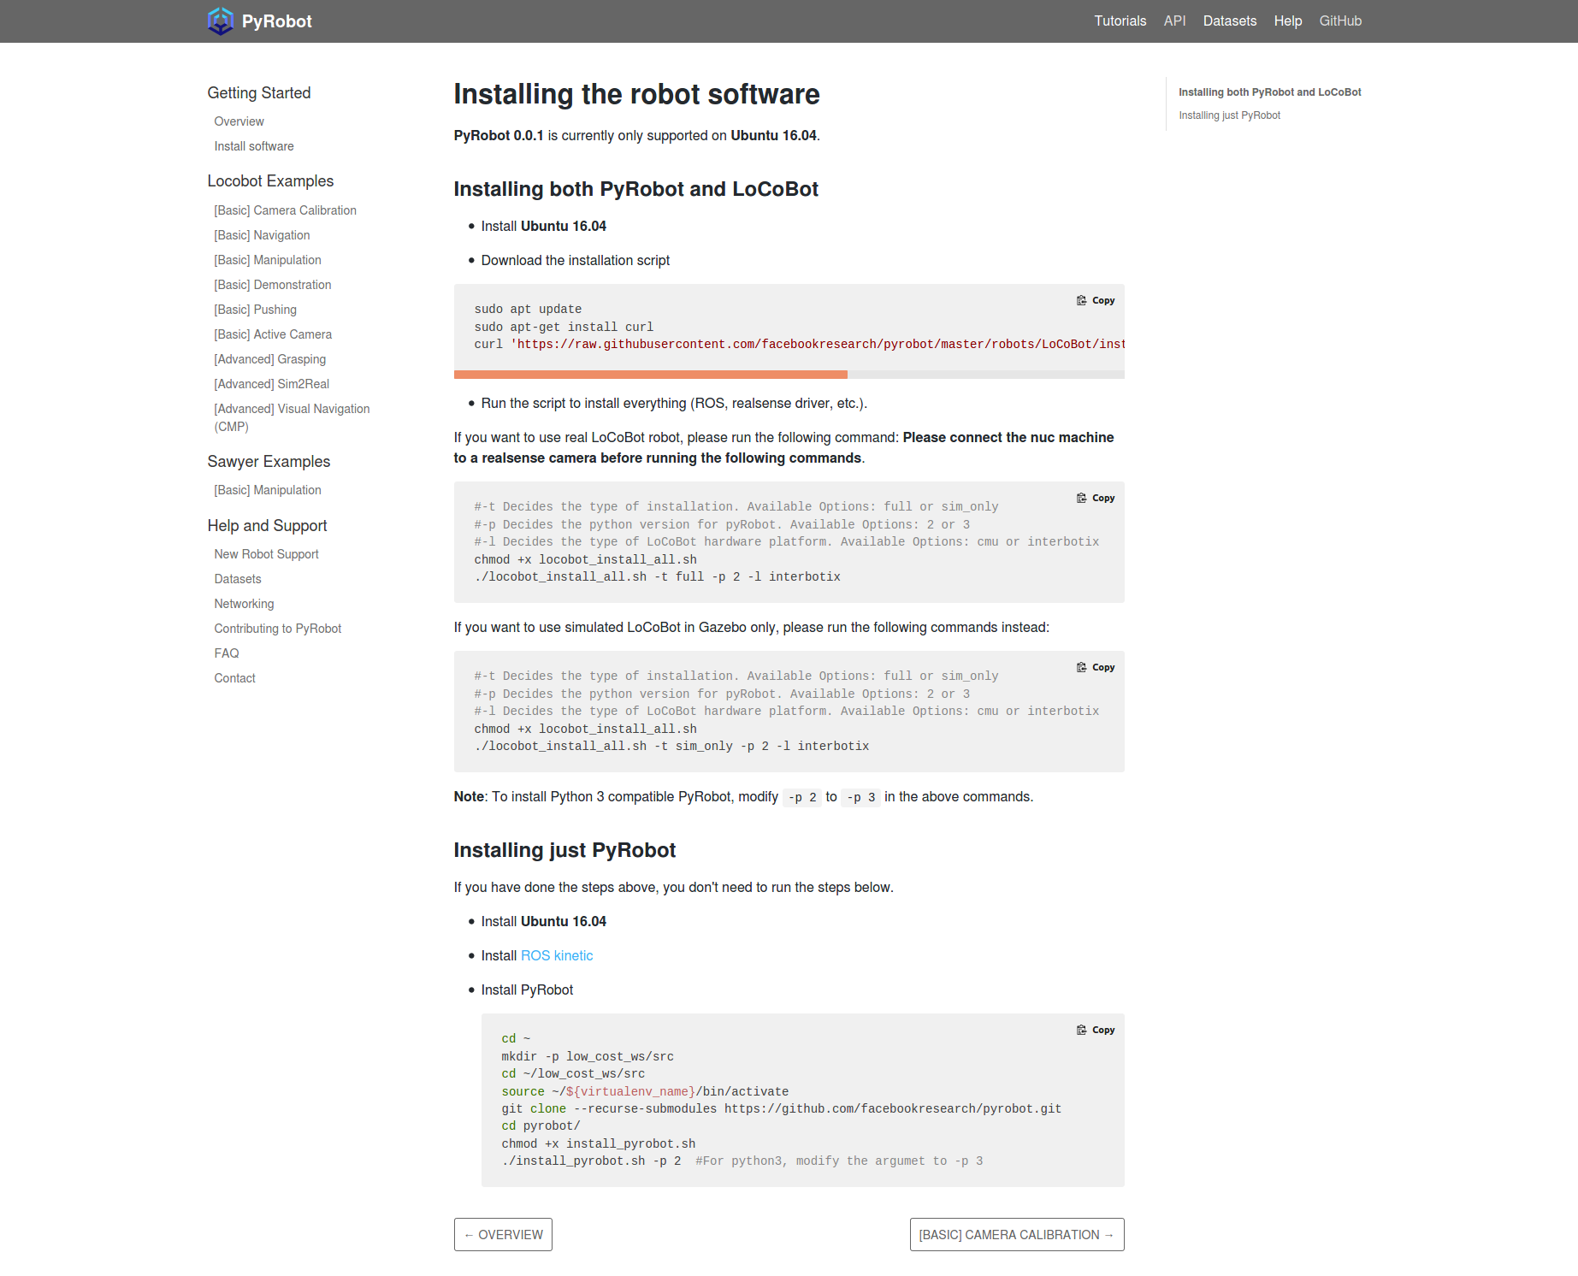
Installing both PyRobot and LoCoBot
- Install Ubuntu 16.04
- Download the installation script
sudo apt update
sudo apt-get install curl
curl 'https://raw.githubusercontent.com/facebookresearch/pyrobot/master/robots/LoCoBot/install/locobot_install_all.sh' > locobot_install_all.sh
If you want to use real LoCoBot robot, please run the following command: Please connect the nuc machine to a realsense camera before running the following commands.
#-t Decides the type of installation. Available Options: full or sim_only
#-p Decides the python version for pyRobot. Available Options: 2 or 3
#-l Decides the type of LoCoBot hardware platform. Available Options: cmu or interbotix
chmod +x locobot_install_all.sh
./locobot_install_all.sh -t full -p 2 -l interbotix

Installing just PyRobot
If you have done the steps above, you don't need to run the steps below.
- Install Ubuntu 16.04
- Install ROS kinetic
- Install PyRobot

cd ~
mkdir -p low_cost_ws/src
cd ~/low_cost_ws/src
source ~/${virtualenv_name}/bin/activate
git clone --recurse-submodules https://github.com/facebookresearch/pyrobot.git
cd pyrobot/
chmod +x install_pyrobot.sh
./install_pyrobot.sh -p 2 #For python3, modify the argumet to -p 3

[Basic] Camera Calibration

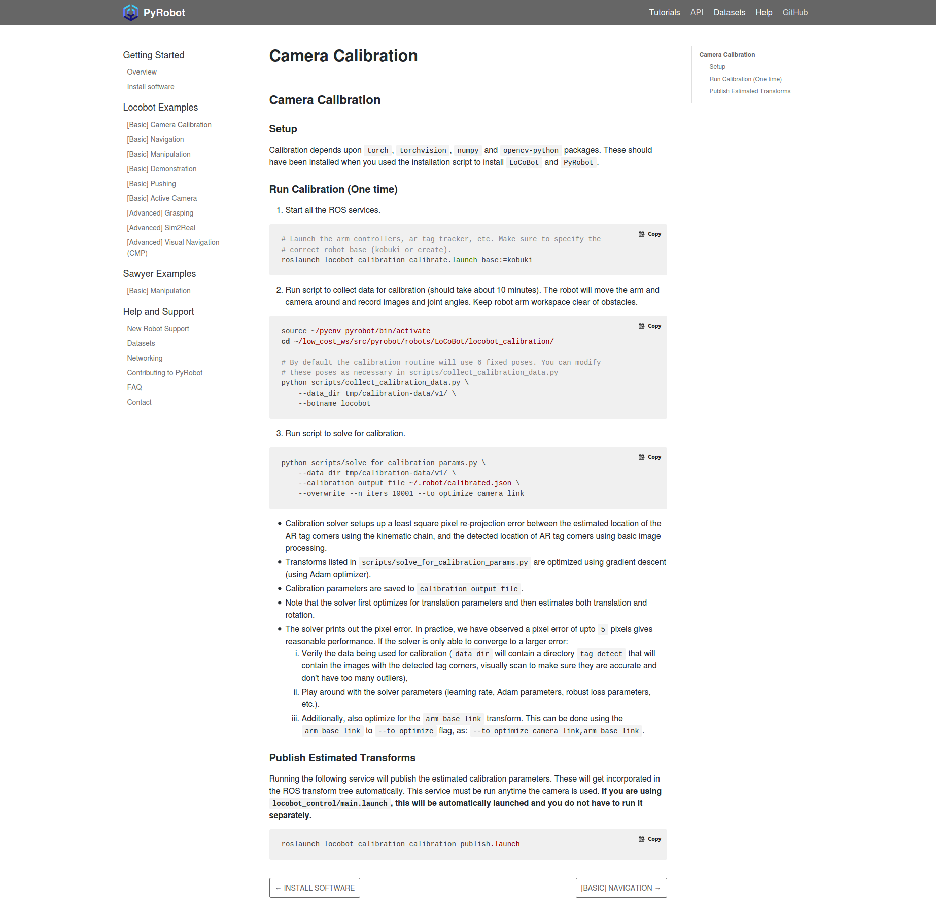
Camera Calibration

Setup
Calibration depends upon torch, torchvision, numpy and opencv-python packages. These should have been installed when you used the installation script to install LoCoBot and PyRobot.

Run Calibration (One time)
- Start all the ROS services.
# Launch the arm controllers, ar_tag tracker, etc. Make sure to specify the
# correct robot base (kobuki or create).
roslaunch locobot_calibration calibrate.launch base:=kobuki
- Run script to collect data for calibration (should take about 10 minutes). The robot will move the arm and camera around and record images and joint angles. Keep robot arm workspace clear of obstacles.
source ~/pyenv_pyrobot/bin/activate
cd ~/low_cost_ws/src/pyrobot/robots/LoCoBot/locobot_calibration/

# By default the calibration routine will use 6 fixed poses. You can modify
# these poses as necessary in scripts/collect_calibration_data.py
python scripts/collect_calibration_data.py \
--data_dir tmp/calibration-data/v1/ \
--botname locobot
- Run script to solve for calibration.
python scripts/solve_for_calibration_params.py \
--data_dir tmp/calibration-data/v1/ \
--calibration_output_file ~/.robot/calibrated.json \
--overwrite --n_iters 10001 --to_optimize camera_link
- Calibration solver setups up a least square pixel re-projection error between the estimated location of the AR tag corners using the kinematic chain, and the detected location of AR tag corners using basic image processing.
- Transforms listed in scripts/solve_for_calibration_params.py are optimized using gradient descent (using Adam optimizer).
- Calibration parameters are saved to calibration_output_file.
- Note that the solver first optimizes for translation parameters and then estimates both translation and rotation.
- The solver prints out the pixel error. In practice, we have observed a pixel error of upto 5 pixels gives reasonable performance. If the solver is only able to converge to a larger error:
  - Verify the data being used for calibration (data_dir will contain a directory tag_detect that will contain the images with the detected tag corners, visually scan to make sure they are accurate and don't have too many outliers),
  - Play around with the solver parameters (learning rate, Adam parameters, robust loss parameters, etc.).
  - Additionally, also optimize for the arm_base_link transform. This can be done using the arm_base_link to --to_optimize flag, as: --to_optimize camera_link,arm_base_link.

Publish Estimated Transforms
Running the following service will publish the estimated calibration parameters. These will get incorporated in the ROS transform tree automatically. This service must be run anytime the camera is used. If you are using locobot_control/main.launch, this will be automatically launched and you do not have to run it separately.
roslaunch locobot_calibration calibration_publish.launch

[Basic] Navigation

Setup
This tutorial can also be run using a simulated version of the robot. Before we get started with this, ensure the following:
- The robot base is supported by PyRobot. Check if your robot is supported here.
- The robot base is switched ON. With the LoCoBot the base beeps when connected.
- The robot's launch file has been run. Note that you have to set use_base:=true.
LoCoBot[Real Robot]
roslaunch locobot_control main.launch use_base:=true
LoCoBot[Simulator]
roslaunch locobot_control main.launch use_base:=true use_sim:=true
- The appropriate python virtual environment has been sourced.
load_pyrobot_env

Base State
Base state is represented by [x, y, yaw], the x-coordinate, y-coordinate of the base_link and the robot heading yaw. By default this state is estimated via intertial sensors, or wheel encoders. This state can be queried as follows (You can run the following code in a python terminal):
Source virtual env
#import appopriate dependencies
from pyrobot import Robot

# Create robot.
robot = Robot('locobot')

# Get the current pose of the base i.e, a state of the form (x, y, yaw). Note
# that over here we are querying the 'odom' state, which is state estimated
# from inertial sensors and wheel encoders on the base.
current_state = robot.base.get_state('odom')

# (Advanced) If you are running visual SLAM, then you can also query the state
# as estimated from visual sensors, using the following. State estimates from
# visual SLAM can be more accurate.
current_state = robot.base.get_state('vslam')

Basic Control
In this section, we will talk about two modes of controlling the LoCoBot base- Velocity control and Position control. One should note the same tutorials also apply to LoCoBot-Lite with very minimal change to the code.
We will talk about velocity and position control by introducing examples.

Velocity control
This mode of control allows us to command the base with a particular linear and angular velocity for a specified ammount of time.
An example script that performs velocity control,
Source virtual env
#import appopriate dependencies
from pyrobot import Robot

# Create the Robot object that interfaces with the robot.
robot = Robot('locobot')
# If you want to use LoCoBot-Lite instead, replace the argument 'locobot' with
# 'locobot_lite'

# linear_velocity in m/s
linear_velocity = 0.1

# rotational_velocity in radian / s
rotational_velocity = 0.5

# execution_time in seconds
execution_time = 4

# Command to execute motion
robot.base.set_vel(fwd_speed=linear_velocity,
turn_speed=rotational_velocity,
exe_time=execution_time)

# To stop the robot at any time:
robot.base.stop()

Frames of reference
As shown in the figure below, there are two frames of reference available for the base - Local and Global frames.
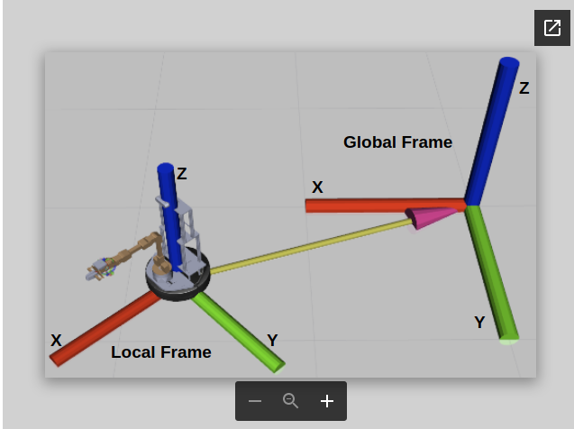

Local frame is the frame of reference attached to the base of the robot and moves with it as the robot moves i.e, all the points in this frame are relative to the robot.
Global frame is a stationary frame of reference. It is the initial frame that the robot started at.

Position control
This mode of control allows us to command the base to go to a specified target (of the form [x, y, yaw]) in the environment.
We currently support three different base-controllers for position control: ILQR, Proportional and Movebase.
Following code shows an example of position control.
from pyrobot import Robot
# base_config_dict is a dictionary that contains different base configuration
# parameters. 'base_controller' can be set to 'ilqr' or 'proportional' or
# 'movebase' to use the respective controllers.
base_config_dict={'base_controller': 'ilqr'}

# crate the Robot object with the specified base_config
robot = Robot('locobot', base_config=base_config_dict)

# target position we want the base to go to
target_position = [1,1,0.5] # this is a 2D pose of the form [x, y, yaw]

# Now command the robot to go to the target pose in the enviroment
# 'go_to_absolute' assumes that the target is in world frame.
robot.base.go_to_absolute(target_position)

# Targets can be specified in robot's coordinate frame.
# robot.base.go_to_relative(target_position)

As shown below, we can also modify go_to_absolute or go_to_relative function arguments to enable or disable different features.
# smooth ensures that the robot only follows smooth motions while going to goal
# smooth mean no on-spot rotations.
robot.base.go_to_absolute(target_position, smooth=True)

# close_loop ensures that the controller acts in closed loop by using onboard
# odommetry
robot.base.go_to_absolute(target_position, close_loop=True)
Below are few different position control examples.
Example 1
from pyrobot import Robot
base_config_dict={'base_controller': 'proportional'}
robot = Robot('locobot', base_config=base_config_dict)
target_position = [1.0, 0.0, 0.0] # go forward 1 meter
robot.base.go_to_relative(target_position, smooth=False, close_loop=True)
Example 2
from pyrobot import Robot
base_config_dict={'base_controller': 'ilqr'}
robot = Robot('locobot', base_config=base_config_dict)
target_position = [-1.0, 0.0, 0.0] # go reverse 1 meter
robot.base.go_to_relative(target_position, smooth=False, close_loop=True)
Example 3
from pyrobot import Robot
base_config_dict={'base_controller': 'movebase'}
robot = Robot('locobot', base_config=base_config_dict)
target_position = [0.0, 0.0, 1.5707] # rotate on-spot by 90 degrees
robot.base.go_to_relative(target_position, smooth=False, close_loop=True)
Example 4
from pyrobot import Robot
base_config_dict={'base_controller': 'ilqr'}
robot = Robot('locobot', base_config=base_config_dict)
target_position = [1.0, 1.0, 0.0]
robot.base.go_to_relative(target_position, smooth=False, close_loop=True)
robot.base.go_to_relative(target_position)

Trajectory Tracking
Feedback controllers implemented in the library can be used to close the loop on a given state-space trajectory. The base state is characterized by [x, y, yaw], the x-coordinate, y-coordinate and the robot heading yaw. Given a state-space trajectory (at the frequency at which the tracker is run), the track_trajectory function can close the loop on the trajectory.
from pyrobot import Robot
import numpy as np
base_config_dict={'base_controller': 'ilqr'}
robot = Robot('locobot', base_config=base_config_dict)

# Generate a straight line trajectory, for the robot to track. Note that this
# trajectory needs to be generated at the frequency of the feedback controller
# that will track it.

# We need to generate a trajectory at the following rate.
dt = 1. / robot.configs.BASE.BASE_CONTROL_RATE

# We will generate a trajectory 1m long and track it such that the robot moves
# at half the max speed of the robot.
v = robot.configs.BASE.MAX_ABS_FWD_SPEED / 2.

# distance moved per time step
r = v * dt

# number of time steps
t = int(1/r)

# initial state
x, y, yaw = robot.base.get_state('odom')

# generate state trajectory
states = []
for i in range(t):
states.append([x+r*np.cos(yaw)*i, y+r*np.sin(yaw)*i, yaw])
states = np.array(states)

# Call trajectory tracker
robot.base.track_trajectory(states, close_loop=True)
In this example, we tracked a very simple trajectory, but the implementation can track more complex trajectories as well. More a more advanced example see here.

Position control with map (Real robot)
Position control with map is an enhanced position control feature that allows us to leverage the map contructed by the onboard SLAM algorithms while going to a specific target in the environement. This feature allows to avoid obstacles in the environment while going to a target postion as the robot only travels through the free space deemed worthy by the onboard SLAM.
To use this feature we need to modify the initially specified launch file arguments as follows,
LoCoBot[Real Robot]
roslaunch locobot_control main.launch use_base:=true use_vslam:=true use_camera:=true
Warning:
- After running the above launch command, please do not move in front of the camera or temporarily block the camera view. These actions would be registered as permanent obstacles by SLAM which is running perpetualy in the background. The SLAM algorithm here does not deal with the dynamic obstacles.
- SLAM only works in environments that have rich RGB feature points and could fail otherwise.
- While using PyRobot, if you launch the robot with different settings, you need to exit the python terminal, and import PyRobot in a new python terminal.
Here is an example showing position control with map in action.
from pyrobot import Robot

# 'base_planner' is the planner used to generate collision free plans to goal
base_config_dict={'base_controller': 'proportional', 'base_planner':'movebase'}

robot = Robot('locobot', base_config=base_config_dict)

# 'use_map' argument determines if map should be used or not in position control.
robot.base.go_to_relative([2.0, 0.0, 0.0], use_map=True, smooth=False, close_loop=True)

[Basic] Manipulation

Setup
This tutorial can also be run using a simulated version of the robot. Before we get started with this, ensure the following:
- The robot arm is supported by PyRobot. Check if your robot is supported here.
- The robot arm is switched ON. With the LoCoBot this is done by connecting the power supply and USB to the arm.
LoCoBot Setup Instructions:

LoCoBot's launch file has been run. Note that you have to set use_arm:=true.
roslaunch locobot_control main.launch use_arm:=true
Similar to the real robot, for LoCoBot gazebo simulator, run the following command,
roslaunch locobot_control main.launch use_arm:=true use_sim:=true

- The appropriate python virtual environment has been sourced before running any PyRobot package.
Source virtual env
load_pyrobot_env

Basic movements
In your favorite Python command shell run the following to setup the robot object
LoCoBot Setup Instructions
from pyrobot import Robot
import numpy as np
impot time
robot = Robot('locobot')
This creates a Robot object that encapsulates the robot's basic motion utilities.

Joint control
To move the joints of the robot to a desired joint configuration, run the following snippet:
LoCoBot
target_joints = [[0.408, 0.721, -0.471, -1.4, 0.920],[-0.675, 0, 0.23, 1,-0.70]]
robot.arm.go_home()
for joint in target_joints:
robot.arm.set_joint_positions(joint, plan=False)
time.sleep(1)
robot.arm.go_home()
Robot.arm.go_home() makes the arm to move to its home position. Since we are using a 5-joint (DoF, degree-of-freedom) arm on the LoCoBot, the target_joint is a 5D vector of desired individual joint angles from the base of the arm to its wrist. Then finally through the set_joint_positions method the Robot will move to the desired target_joint. The plan=False argument means that the robot will not use MoveIt to plan around obstacles (like the base or the arm itself). To plan around obstacles, look at using MoveIt.

End-effector pose control
In this example, we will look at controlling the end-effector pose of the arm. A pose object has two components: position and rotation. Position is a 3D numpy array representing the desired position. Orientation can be a rotation matrix [3x3], euler angles [3,], or quaternion [4,].
LoCoBot
import time
target_poses = [{'position': np.array([0.279, 0.176, 0.217]),
'orientation': np.array([[0.5380200, -0.6650449, 0.5179283],
[0.4758410, 0.7467951, 0.4646209],
[-0.6957800, -0.0035238, 0.7182463]])},
{'position': np.array([0.339, 0.0116, 0.255]),
'orientation': np.array([0.245, 0.613, -0.202, 0.723])},
]
robot.arm.go_home()
for pose in target_poses:
robot.arm.set_ee_pose(**pose)
time.sleep(1)
robot.arm.go_home()
Note that since the LoCoBot only has 5 DoFs, it can only reach target poses that lie in its configuration space. Check the API for more on how to use the method set_ee_pose.

End-effector Position and Pitch Roll Control
This is a LoCoBot-specific example.
As LoCoBot is a 5-DOF robot, you can specify its pose with an end-effector position (x,y,z), a pitch angle and a roll angle (no need to specify yaw angle as it only has 5 degrees of freedom).
target_poses = [
{'position': np.array([0.28, 0.17, 0.22]),
'pitch': 0.5,
'numerical': False},
{'position': np.array([0.28, -0.17, 0.22]),
'pitch': 0.5,
'roll': 0.5,
'numerical': False}]

robot.arm.go_home()

for pose in target_poses:
robot.arm.set_ee_pose_pitch_roll(**pose)
time.sleep(1)
robot.arm.go_home()

End-effector Cartesian Path control
In this example, we will move the arm in the X,Y,Z coordinates in straight-line paths from the current pose.
LoCoBot
robot.arm.go_home()
displacement = np.array([0, 0, -0.15])
robot.arm.move_ee_xyz(displacement, plan=True)
robot.arm.go_home()
If plan=True, it will call the internal cartesian path planning in MoveIt.
If plan=False, it will simply perform linear interpolation along the target straight line and do inverse kinematics (you can choose whether you want to use the numerical inverse kinematics or analytical inverse kinematics by passing numerical=True or numerical=False) on each waypoints. Since LoCoBot is a 5-DOF robot, the numerical inverse kinematics sometimes fail to find the solution even though there exists a solution. So analytical inverse kinematics might work better in such cases.

Joint torque control
Warning for usage. Each though each joint accepts the torque command, there is no gravity compensation implemented for LoCoBot yet. Torque control mode is not recommended for LoCoBot and it's not well tested. Sawyer does support torque control and it's well tested.
For direct torque control, one can use the set_joint_torques method as follows. Firstly, you will need to kill the previously launched driver and relaunched it with the following command.
LoCoBot Only
roslaunch locobot_control main.launch use_arm:=true torque_control:=true
Then you can use the following command to send torque values to robots. Try to keep the arm in initial condition as shown in the below video, as the behavior will be different for a different configuration. For this example, we are going to apply torque only on joint 4. This will move robot joint 4 to the extreme. After completion, the joint will be free again. The torque requirements may vary from robot to robot. So if joint 4 doesn't move using following script, try to apply a higher magnitude of torque.
LoCoBot
from pyrobot import Robot
import time
arm_config = dict(control_mode='torque')
robot = Robot('locobot', arm_config=arm_config)
target_torque = 4 * [0]
target_torque[3] = -0.45
robot.arm.set_joint_torques(target_torque)
time.sleep(2)
target_torque[3] = 0.0
robot.arm.set_joint_torques(target_torque)

Gripper control
Opening and closing the gripper is done via the gripper object.
import time

robot.gripper.open()
time.sleep(1)

robot.gripper.close()

Planning using MoveIt
To avoid hitting obstacles like the base or the arm itself, we support planning via MoveIt!. To use this, we need to first set the robot with the approriate planning parameters:
LoCoBot
config = dict(moveit_planner='ESTkConfigDefault')
robot = Robot('locobot', arm_config=config)
After this run set_joint_positions with the argument plan=True.
LoCoBot
target_joints = [
[0.408, 0.721, -0.471, -1.4, 0.920],
[-0.675, 0, 0.23, 1, -0.70]
]
robot.arm.go_home()
for joint in target_joints:
robot.arm.set_joint_positions(joint, plan=True)
time.sleep(1)
robot.arm.go_home()

Sensing
Most arms come with proprioceptive feedback. The following functions can be used to read the current state of the robot (joint angles, velocities, torques), etc.
# Get all joint angles of the robot
current_joints = robot.arm.get_joint_angles()

# Get state of a specific joint
current_joint = robot.arm.get_joint_angle("joint_5")

# Get all joint velocities of the robot
current_velocity = robot.arm.get_joint_velocities()

# Get current joint torques (if mode='torque')
current_torques = robot.arm.get_joint_torques()

[Basic] Demostration

Getting started
- Make sure robot is turned ON
- Launch the robot server. Note that you have to set teleop:=true. Pass in the corresponding flags when launching the robot.
LoCoBot Arm [Real]
# You will only be able to control the arm (no base and no camera)
roslaunch locobot_control main.launch use_arm:=true teleop:=true
Arm+Base [Real]
# You will only be able to control the arm and the base
roslaunch locobot_control main.launch use_arm:=true use_base:=true teleop:=true
Arm+Base+Camera [Real]
# You will only be able to control the arm, the base, and the camera
roslaunch locobot_control main.launch use_arm:=true use_base:=true use_camera:=true teleop:=true
Arm+Base+Camera [Gazebo]
roslaunch locobot_control main.launch use_arm:=true use_sim:=true teleop:=true use_camera:=true use_base:=true
- Start the teleop server in a new terminal
load_pyrobot_env
cd ~/low_cost_ws/src/pyrobot/robots/LoCoBot/locobot_control/nodes
python robot_teleop_server.py
- Now we can run the teleoperation client (in a new terminal). The screen should display the relevant commands to control the arm.
load_pyrobot_env
cd ~/low_cost_ws/src/pyrobot/robots/LoCoBot/locobot_control/nodes
python keyboard_teleop_client.py

[Basic] Pushing

Get Started
Note This tutorial is tested to work only with Python2.7 version on PyRobot
- Make sure robot is turned ON
- Launch the robot driver
Launch driver
roslaunch locobot_control main.launch use_arm:=true use_camera:=true
- Run the pushing example
pushing.py script accepts two parameters: floor_height and gripper_len. You need to tune these two parameters a bit. floor_height means the z-coordinate of the floor. Points with z-coordinate smaller than this value will be filtered. Only points heigher than the floor will be used for clustering. gripper_len means the length of the gripper (from gripper_link to the tip of the gripper). You may need to tune these two parameters when you run the example.
If the gripper goes down too much and it hits the floor while pushing the object, you can make the gripper_len bigger. If the gripper doesn't go down enough and it doesn't touch the object, you can try making the gripper_len smaller.
To tune floor_height, you need to run the following script first.
Visualize filtered point cloud
source ~/pyenv_pyrobot/bin/activate
cd ~/low_cost_ws/src/pyrobot/examples/locobot/manipulation
python realtime_point_cloud.py --floor_height=0.01
This script shows the point cloud in the scene after filtering (points with depth more than 1.5m and points with z coordinate (height) larger than floor_height will be removed). The remaining point cloud will be used for clustering and pushing in pushing.py. So you need to tune the floor_height such that the floor is completely removed (which means its value cannot be too small) and as much points of the the objects as possible are remained (which means its value cannot be too big).
After tuning, you can run the pushing script in a new terminal as follows:
Run pushing script
source ~/pyenv_pyrobot/bin/activate
cd ~/low_cost_ws/src/pyrobot/examples/locobot/manipulation
python pushing.py --floor_height=0.01 --gripper_len=0.12
Warning: we are using the analytical inverse kinematics in this example, which means no collision checking is performed here. So the robot arm may hit the robot itself sometimes.

[Basic] Active Camera

Getting started
- Make sure robot is turned ON
- Launch the robot driver
Launch driver
roslaunch locobot_control main.launch use_camera:=true
- Start the python virtual environment
Source virtual env
load_pyrobot_env

Example usage
- Initialize a robot instance
Create robot
from pyrobot import Robot
bot = Robot('locobot')
bot.camera.reset()
- Set camera pan or tilt angle, or set pan and tilt angles together
Set Pan
pan = 0.4
bot.camera.set_pan(pan, wait=True)
Set Tilt
tilt = 0.4
bot.camera.set_tilt(tilt, wait=True)
Set Pan and Tilt
camera_pose = [0, 0.7]
bot.camera.set_pan_tilt(camera_pose[0], camera_pose[1], wait=True)

- Get rgb or depth images
RGB
from pyrobot.utils.util import try_cv2_import
cv2 = try_cv2_import()
rgb = bot.camera.get_rgb()
cv2.imshow('Color', rgb[:, :, ::-1])
cv2.waitKey(3000)
Depth
from pyrobot.utils.util import try_cv2_import
cv2 = try_cv2_import()
import numpy as np
depth = bot.camera.get_depth()
actual_depth_values = depth.astype(np.float64) / 1000.0
cv2.imshow('Depth', depth)
cv2.waitKey(3000)
RGB and Depth
from pyrobot.utils.util import try_cv2_import
cv2 = try_cv2_import()
rgb, depth = bot.camera.get_rgb_depth()
cv2.imshow('Color', rgb[:, :, ::-1])
cv2.imshow('Depth', depth)
cv2.waitKey(3000)
- Get 3D point coordinates of pixels in RGB image
In manipulation, we often get into the case where we want to know where an RGB pixel is in the 3D world, meaning the correspondence between RGB pixels and their 3D locations with respect to the robot. In PyRobot, we have provided a utility function (pix_to_3dpt) to do this transformation. This function takes as input the row indices and column indices of the pixels. It will return the 3D point locations and the RGB color values of these pixels. You can specify in_cam=True to get the 3D locations in the camera frame. Otherwise, the 3D locations will be with respect to the LoCoBot base frame.
Pixel via Scalar
bot.camera.set_tilt(0.6)
r = 295 # row number in the RGB image
c = 307 # column number in the RGB image
pt, color = bot.camera.pix_to_3dpt(r,c)
print('3D point:', pt)
print('Color:', color)
rgb = bot.camera.get_rgb()
cv2.imshow('Color', rgb[:, :, ::-1])
cv2.waitKey(10000)

Pixels via List
bot.camera.set_tilt(0.6)
r = [295, 360]
c = [307, 296]
# this will return the point and color of
# pixel (295, 307) and pixel (360, 296)
pt, color = bot.camera.pix_to_3dpt(r,c)
print('3D point:', pt)
print('Color:', color)
rgb = bot.camera.get_rgb()
cv2.imshow('Color', rgb[:, :, ::-1])
cv2.waitKey(10000)
Pixels via Numpy Array
import numpy as np
bot.camera.set_tilt(0.6)
r = np.array([295, 360])
c = np.array([307, 296])
# this will return the point and color of
# pixel (295, 307) and pixel (360, 296)
pt, color = bot.camera.pix_to_3dpt(r,c)
print('3D point:', pt)
print('Color:', color)
rgb = bot.camera.get_rgb()
cv2.imshow('Color', rgb[:, :, ::-1])
cv2.waitKey(10000)

[Advanced] Grasping

Getting started
Here we demonstrate how the PyRobot API can be used to grasp objects by using a learned model. Ideally PyRobot has already been installed, which will allow us to use the Python API for basic robot operations. Before we get started with this, ensure the following:
- The robot arm is supported by PyRobot. Check if your robot is supported here.
- The robot arm is switched ON. With the LoCoBot this is done by connecting the power supply and USB to the arm.
- Setup the virtual environment. Since the grasp models we are using need PyTorch, we need to install it in a new virtual environment. To do this easily, run the following lines.
virtualenv_name="pyenv_locobot_grasping"
virtualenv --system-site-packages -p python ~/${virtualenv_name}
source ~/${virtualenv_name}/bin/activate
cd ~/low_cost_ws/src/pyrobot
pip install -e .
cd ~/low_cost_ws/src/pyrobot/examples/grasping
pip install -r requirements.txt
- The robot's launch file has been run. Note that you have to set use_arm:=true and use_camera:=true.
roslaunch locobot_control main.launch use_arm:=true use_camera:=true

Running the example
We use a sampling based grasping algorithm to grasp objects using the LoCoBot. The grasping script locobot.py accepts 4 parameters: n_grasps, n_samples, patch_size, and no_visualize. n_grasps is the number of times the robot attempts a grasp. n_samples is the number of samples of size patch_size that are input into the grasp model. The larger the number of samples, the more is the inference time. Infering on 100 patches should take around 30 seconds on the NUC. After every grasp inference, a window showing the best found grasp is displayed until the user hits the space key. Running the script with --no_visualize disables this visualization.
source ~/pyenv_locobot_grasping/bin/activate
cd ~/low_cost_ws/src/pyrobot/examples/grasping
python locobot.py --n_grasps=5 --n_samples=100 --patch_size=100

[Advanced] Sim2Real

What is Sim2Real?
In this section we will train a simple RL policy which will learn inverse kinematics for the arm using RL(TD3). The input to the RL agent is state(joint angles of arm) & goal location(x,y,z) and the control action is the change in each joint angles to achieve the desired goal.
For TD3 implementation , we used the publicly available code.
Here is a demo video showing what one can accomplish through this tutorial.

Installation
- Activate the virtual environment
Source virtual env
source ~/pyenv_pyrobot/bin/activate
- Install Dependencies
pip install gym
pip install pybullet
- Start by either training the agent from scratch or downloading pretrained model
Train the agent (this might take around an hour)
cd ~/low_cost_ws/src/pyrobot/examples/sim2real
python train.py --exp_name expID01 --valid_goals --save_models
Download pretrained model
cd ~/low_cost_ws/src/pyrobot/examples/sim2real
wget -O log.zip https://www.dropbox.com/s/8cttp55odd7e79o/log.zip?dl=0
unzip log.zip
rm log.zip
- Launch the real robot (open a new terminal）
roslaunch locobot_control main.launch use_arm:=true
- Test the above trained policy on the real robot
source ~/pyenv_pyrobot/bin/activate
cd ~/low_cost_ws/src/pyrobot/examples/sim2real
python test.py --use_real_robot --valid_goals --directory ./log/expID01/pytorch_models --file_name LocoBotEnv-v0_0

[Advanced] Visual Navigation
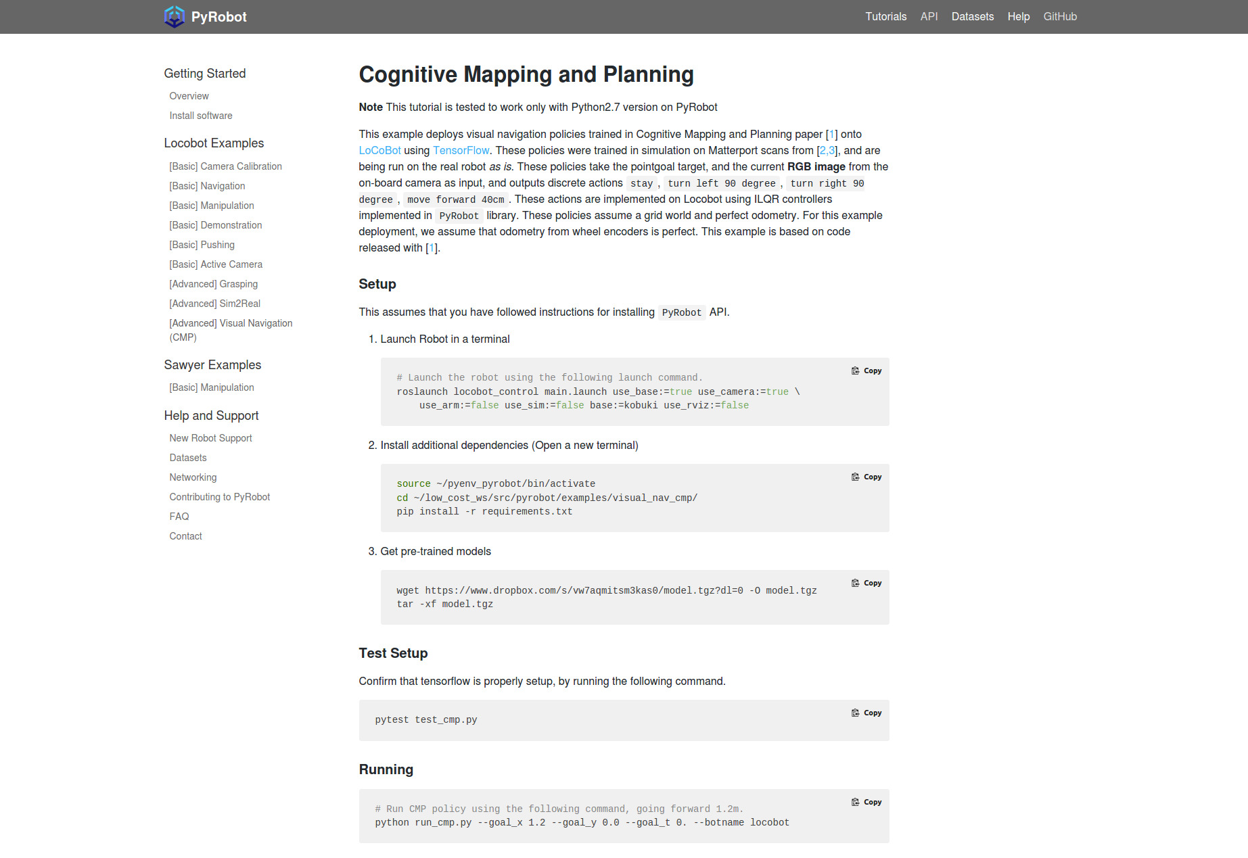
1. Launch Robot in a terminal
# Launch the robot using the following launch command.
roslaunch locobot_control main.launch use_base:=true use_camera:=true \
use_arm:=false use_sim:=false base:=kobuki use_rviz:=false

2. Install additional dependencies (Open a new terminal)
source ~/pyenv_pyrobot/bin/activate
cd ~/low_cost_ws/src/pyrobot/examples/visual_nav_cmp/
pip install -r requirements.txt

3. Get pre-trained models
wget https://www.dropbox.com/s/vw7aqmitsm3kas0/model.tgz?dl=0 -O model.tgz
tar -xf model.tgz

Test Setup
Confirm that tensorflow is properly setup, by running the following command.
pytest test_cmp.py

Running
# Run CMP policy using the following command, going forward 1.2m.
python run_cmp.py --goal_x 1.2 --goal_y 0.0 --goal_t 0. --botname locobot

Demo Runs
1. Go forward 4m:
python run_cmp.py --goal_x 4.0 --goal_y 0.0 --goal_t 0. --compensate
2. Go forward 2m, left 2.4m:
python run_cmp.py --goal_x 2.0 --goal_y 2.4 --goal_t 0. --compensate
3. Go forward 3.2m:
python run_cmp.py --goal_x 3.2 --goal_y 0.0 --goal_t 0. --compensate

